**Assignment 2**

**Name: Shashank Sharma**

**Roll no: J062**

**Btech Data Science**

**Subject - IOT**

**Q1 –**

int value = 0;

void setup()

{

pinMode(9, OUTPUT);

pinMode(A0, INPUT);

Serial.begin(9600);

}

void loop()

{

value = analogRead(A0);

tone(9,map(value,0,1023,120,1500));

Serial.println("\n");

Serial.println(value);

delay(2);

}

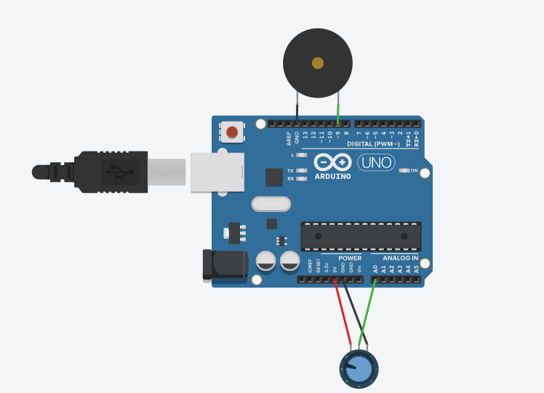

Q2 –

void setup()

{

pinMode(2, OUTPUT);

pinMode(3, OUTPUT);

pinMode(4, OUTPUT);

pinMode(5, OUTPUT);

}

void loop()

{

digitalWrite(2, HIGH);

delay(3000);

tone(5, 440);

delay(2000);

noTone(5);

digitalWrite(2, LOW);

for(int i=0;i<5;i++)

{

digitalWrite(3, HIGH);

delay(500);

digitalWrite(3, LOW);

delay(500);

}

digitalWrite(3, LOW);

digitalWrite(4, HIGH);

delay(3000);

tone(5, 440);

delay(2000);

noTone(5);

digitalWrite(4, LOW);

}

